Federal Election Social Media Toolkit
Click here to download graphics (jpeg and gif).
To increase the impact of your posts:
- Personalize your message.
- Tag your candidates and the party leaders.
- Use a few relevant hashtags like #canpoli or #election2021.
Sample Post | Graphics (click here to download)
 | Landscape (Twitter, Facebook) | Square (Instagram)
Domestic and sexual abuse impacts every Canadian community and family. It’s time our politicians took notice. #canpoli #election2021 | 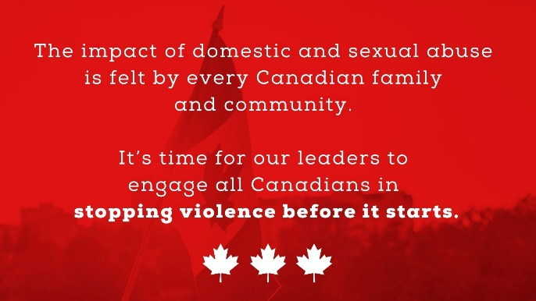 | 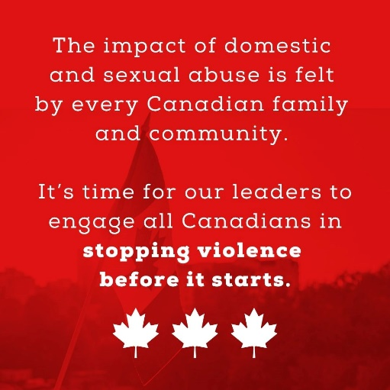

Sample Post | Graphics
 | Landscape (Twitter, Facebook) | Square (Instagram)
Sexual and domestic abuse isn’t just a women’s issue – and shouldn’t be the sole responsibility of @WAGE_FEGC We must recognize male and 2SLGBTQ+ experiences and the role of every Canadian in violence prevention. #canpoli | 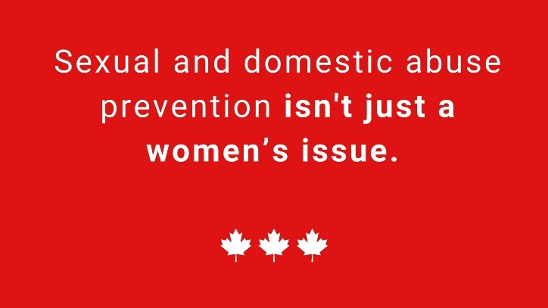 | 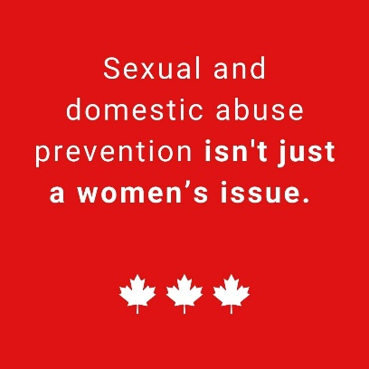
Relationships where coercive control is used have more frequent and severe violence, including lethal violence. Will your government criminalize coercive control @JustinTrudeau? #canpoli  Criminalizing coercive control in intimate relationships would empower police and our justice system to intervene to prevent escalating violence. Will your government criminalize coercive control @erinotoole? #canpoli  NDP candidate @r_garrison private member’s bill proposed the criminalization of coercive control. Will you follow his lead @theJagmeetSingh? #canpoli  The multi-party JUST Committee recommended the criminalization of coercive control, and more than 1,000 Canadians signed a petition advocating for it. Canadians care about this issue; do you @JustinTrudeau @erinotoole @theJagmeetSingh #canpoli | 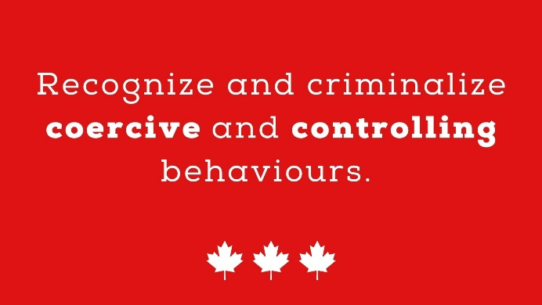 | 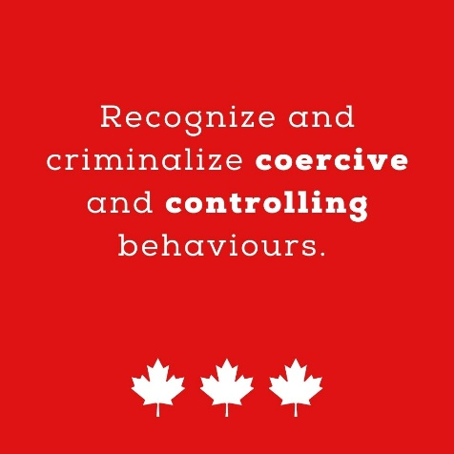
About 36% of spousal abuse victims access formal supports like shelters or crisis lines, while 68 percent talk to their friends and family. We must direct our support where it is most effective: community-based initiatives and informal supports. #canpoli  The best way to prevent domestic abuse is through community-based initiatives and informal supports. Would your government ensure these efforts are properly funded? @JustinTrudeau @erinotoole @theJagmeetSingh #canpoli | 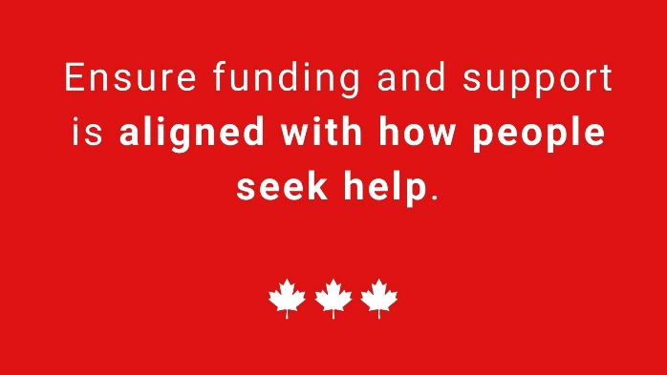 | 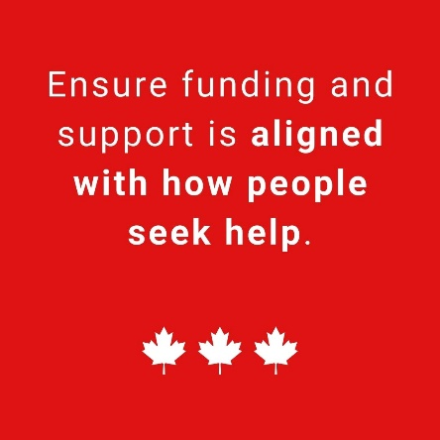
Sexual exploitation is more than trafficking. Will your government release a sexual exploitation action plan which includes prevention, protection and prosecution? @JustinTrudeau @erinotoole @theJagmeetSingh #canpoli #election2021 | 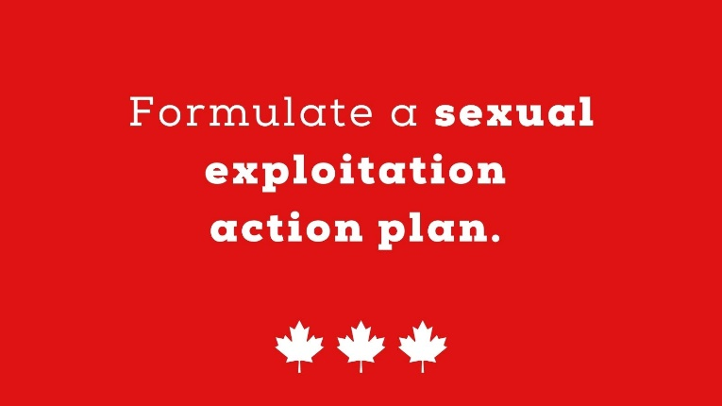 | 